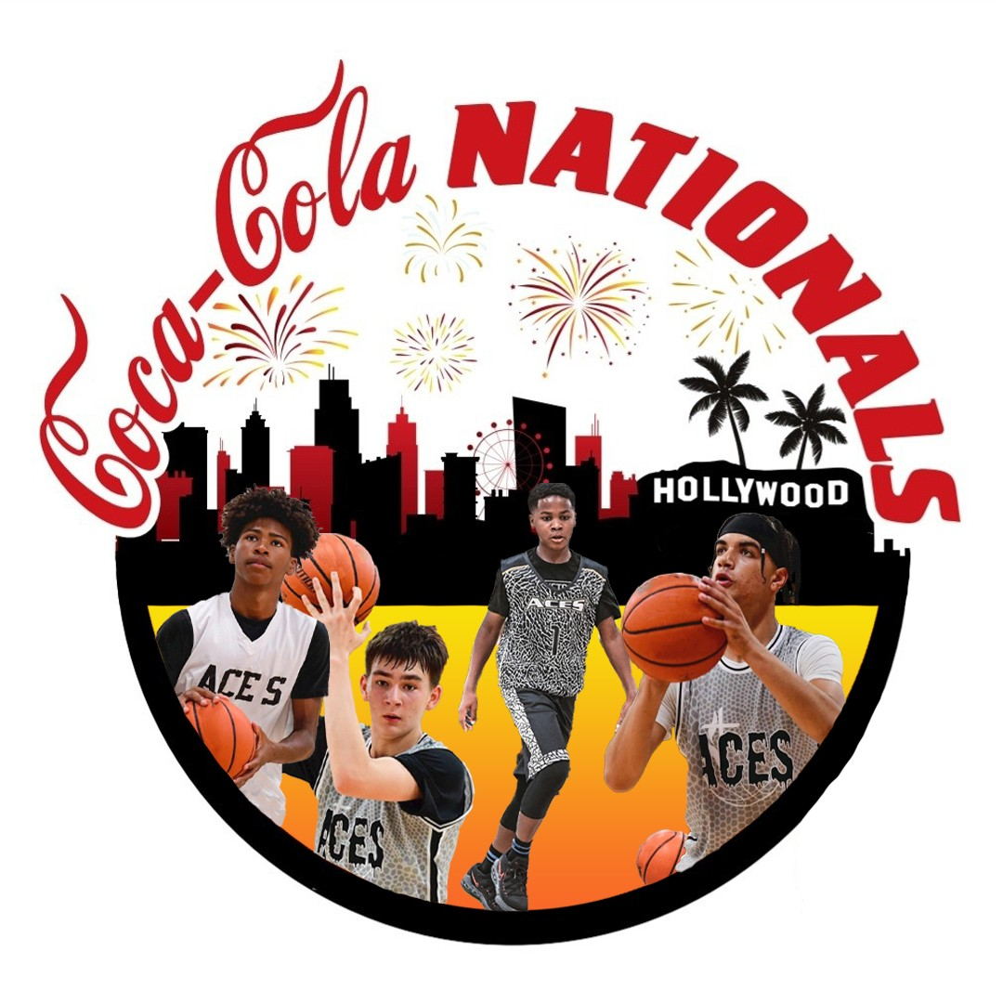
Please ✔check one
DIVISION: INV AGE: 8U
Platinum 9U
Gold 10U
Silver 11U
Bronze 12U
13U
14U HIGH SCHOOL

2022 COCA COLA NATIONAL TOURNAMENT ROSTER
Please ✔check one

TEAM NAME:
ADDRESS:
HEAD COACH :

PHONE NUMBER: EMAIL ADDRESS:

Coaches/Team Manager must have copies of birth certificates and current report cards must be in the team possession at all times.
1  2  3  4  5  6  7  8  9  10  11  12 | PLAYER NAME | DATE OF BIRTH | AGE | GRADE | UNIFORM NO. | GRADE EXCEPTION  Yes or No | COMMENTS |  | ACES APPROVAL  (Initial)
BASKETBALL PLAYER WAIVER, RELEASE OF LIABILITY, INDEMNIFICATION, AND ROSTER FORM
The undersigned Coach & Player (representing for parent or legal guardian of a minor player ) states and agrees as follows:
- The undersigned agrees that player voluntarily participates in playing basketball and assumes all risks associated with such play.
- The undersigned acknowledges that there are risks and hazards in playing basketball including, but not limited to, those caused by court conditions, playing conditions, equipment and other participants, in addition to the acts of dribbling, passing, shooting, and dunking a basketball, running, jumping, stretching, sliding, diving and collisions with other players, spectators, or stationary objects, any of which may cause death or serious injury to the player.
- In consideration of the Aces Basketball Coca Cola Tournament allowing play on the courts, I agree to indemnify and hold harmless and release Aces Basketball, their officials, employees, agents and assigns from any and all claims, demands, lawsuits, costs and attorneys fees arising out of playing in the tournament listed above. This release and indemnification shall be effective and bind any and all heirs, dependents, executors and assigns.
- Payment Acknowledgment: I hereby authorize Aces Basketball/Prince Cassell to charge my and/or a team representatives credit card, paypal,CashApp, Venmo, and/or Zelle account for the deposit/tournament fees.
- I ACKNOWLEDGE that I have read the foregoing instrument and understand its terms and agree to abide by its terms and conditions. I am in agreement that the above player information is true and correct.
ADDITIONAL COACH NAME
COACH NAME
HEAD COACH SIGNATURE PRINT NAME
1

