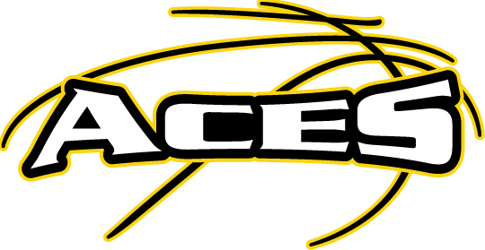

2021-2022 COVID-19 RELEASE OF LIABILITY FORM

The World Health Organization has declared the novel Coronavirus (COVID-19) a worldwide pandemic. Due to its capacity to transmit from person-to-person through respiratory droplets, the government has set recommendations, guidelines, and some prohibitions which (ACES Basketball) adheres to comply.
In consideration of my child’s participation in the program, I acknowledge and agree to the following:
- I am aware of the existence of the risk on my physical appearance to the venue and my participation to the activities of the Organization that may cause injury or illness such as, but not limited to Influenza, or COVID-19 that may lead to sickness or death.

- I have not experienced symptoms that of fever, fatigue, difficulty in breathing, or dry cough or exhibiting any other symptoms relating to COVID-19 or any communicable disease within the last 14 days.

- I have not been, nor any member(s) of my household, diagnosed to be infected of COVID-19 virus within the last 30 days.

I am fully and personally responsible for my own safety and actions while and during any participation and I recognize that I may be at risk of contracting COVID-19.
- With full knowledge of the risks involved, I hereby release, waive, discharge the Organization, its board, officers, independent contractors, affiliates, employees, representatives, successors, and assigns from any and all liabilities, claims, demands, actions, and causes of action whatsoever, directly or indirectly arising out of or related to any loss, damage, injury, or death, that may be sustained by me, (my child) related to COVID-19 while participating in any activity while in, on, or around the premises or while using the facilities that may lead to unintentional exposure or harm due to COVID-19.
- I agree to indemnify, defend, and hold harmless the Organization from and against any and all costs, expenses, damages, lawsuits, and/or liabilities or claims arising whether directly or indirectly from or related to any and all claims made by or against any of the released party due to injury, loss, or death from or related to COVID-19.

By signing below I acknowledge that I have read the foregoing Liability Release Waiver and understand its contents; That I am giving permission for my child’s participation in the program; That I have been sufficiently informed of the risks involved and give my voluntary consent in signing it as my own free act and deed; that I give my voluntary consent in signing this Liability Release Waiver as my own free act and deed with full intention to be bound by the same, and free from any inducement or representation.
This waiver will remain effective until laws and mandates relevant to COVID-19 are lifted.

____________________________ ________________________ ________
Name of Participant (Print) Signature of Participant Date

____________________________ ________________________ ________
Name of Parent or Legal Guardian (Print) Signature of Parent or Legal Guardian Date

“Athletes Changing their Environment Successfully”
www.socalacesbasketball.com

